**Report Title:**

**TK - 1210.01 - 06/05/25**

**Department:**

**Payload**

**Report Date:**

**06/05/2025**

**Report Author:**

**Seyed Ali Rashidi - Payload**

**Review/Approval:**

**Pierluca De Felice - Head - Payload**

**Review/Approval Date:**

**05/05/2025**

**Numerical Evaluation of SNR and Launch Timing Optimization**

This report evaluates how altitude and background temperature affect the Signal-to-Noise Ratio (SNR), with the goal of proposing an optimal satellite launch timing. The analysis is based on Random Forest feature importance, SNR-altitude relationships, and monthly environmental data.

The *Feature Importance* figure confirms that **altitude** is by far the most significant factor influencing SNR, followed by **background temperature**. Outlier detection results (see *Outlier Detection* and *Outlier Data (Altitude vs SNR)*) show that the highest SNR values occur at low altitudes, particularly below 350 km.

Frequency distributions (altitude, month, and their corresponding outliers) reveal that most low-altitude passes — where SNR outliers are found — coincide with the warmest months. This is supported by the *Background Temperature vs Month* figure, which shows peak temperatures during these periods.

Filtered SNR distributions highlight that when altitude is below 350 km, SNR increases substantially, and these data align closely with the outlier SNR distributions. This emphasizes that **low altitude is the main driver of SNR outliers**.

**Conclusion**

To maximize image quality, it is recommended to adjust the satellite launch timing so that the **low-altitude phase occurs during the coldest months**. This strategy leverages both altitude and background temperature effects, ensuring the outliers (which represent high-quality data points) are obtained when conditions are most favorable.

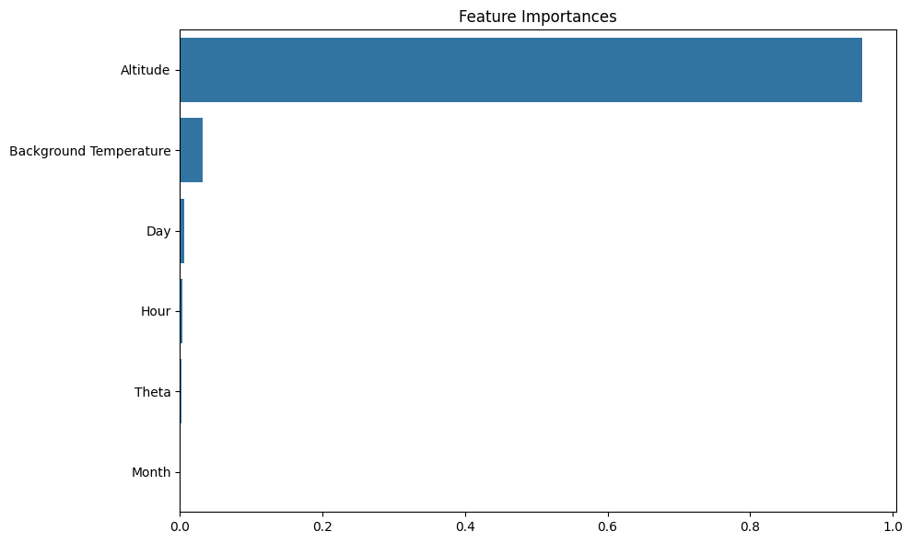

Figure 1: Feature Importance

The *Feature Importance* figure, **extracted from a Random Forest algorithm**, confirms that **altitude** is by far the most significant factor influencing SNR, followed by **background temperature**. These two parameters dominate the model, while other features such as month, hour, and theta have negligible contributions. This result directly supports the focus on altitude and background temperature in planning for optimal image quality.

Figure 2: Outlier detection (SNR vs Altitude)

Figure 3: Outlier data (SNR vs Altitude)

Outliers were identified using statistical analysis of the SNR-altitude data. These figures show that the highest SNR values — detected as outliers — occur predominantly at low altitudes, highlighting the strong inverse relationship between altitude and SNR.

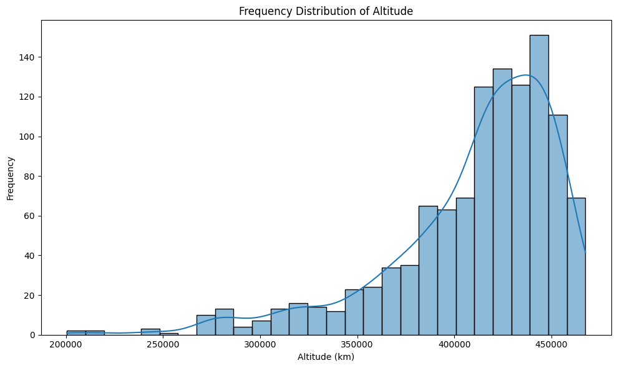

Figure 5: Frequency Distribution of Month for Outliers

These figures illustrate the distribution of altitude for all data and for the detected outliers. The results show that outliers are concentrated at lower altitudes, where the SNR values are significantly higher.

Figure 4: Frequency Distribution of Altitude

Figure 7: Frequency Distribution of Month for Outliers

These figures compare the monthly distribution of all data points and outliers. The outliers are predominantly found during the warmest months, indicating that high SNR events at low altitudes often occur when background temperature is highest.

Figure 6: Frequency Distribution of Month

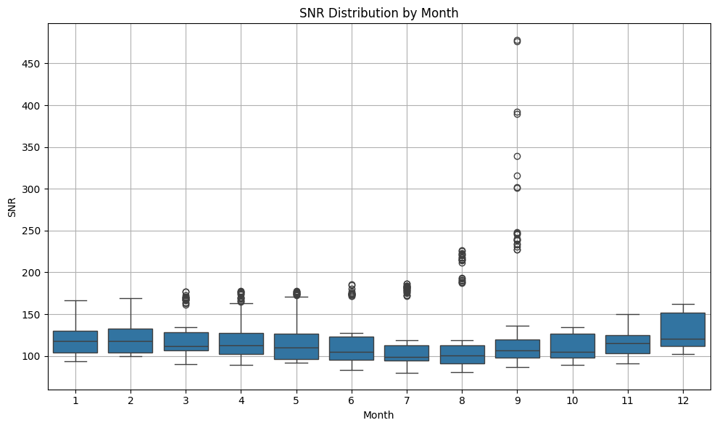

Figure 9: Outlier SNR Distribution by Month

These figures present the overall SNR distribution and the outlier SNR distribution across months. They highlight that the highest SNR values — corresponding to outliers — occur mainly during the warm months, where low altitude coincides with elevated background temperature. However, at the **same altitude**, SNR values would be even higher if those low-altitude passes occurred during **colder months**, due to the additional positive impact of lower background temperature on radiometric contrast.

Figure 8: SNR Distribution by Month

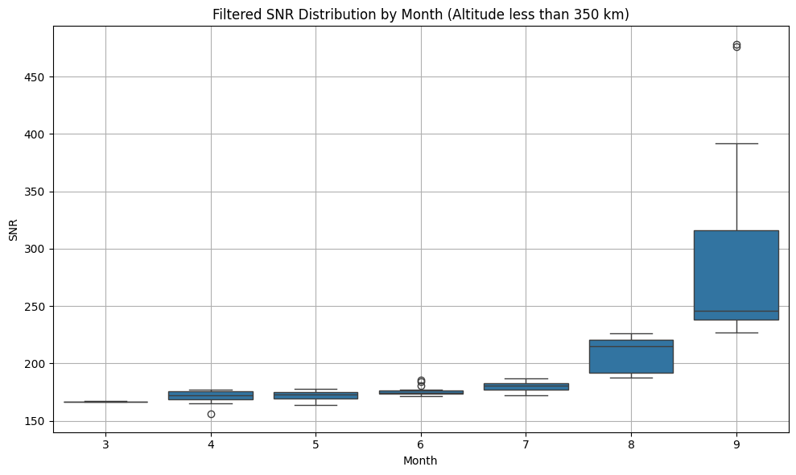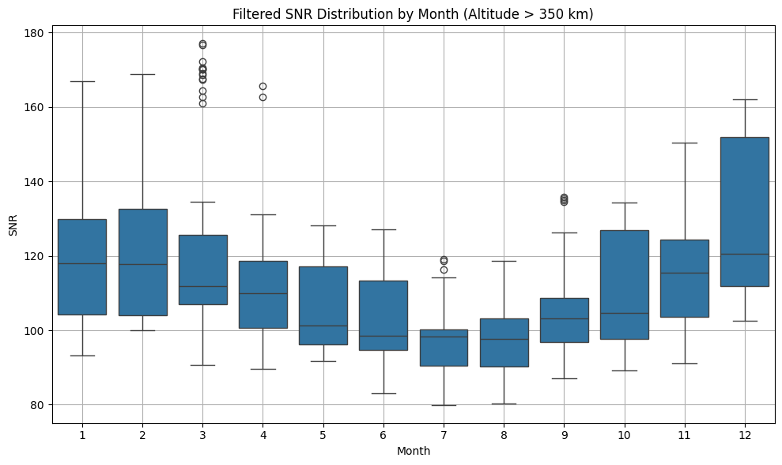

Figure 11: Filtered SNR Distribution by Month (Altitude < 350 km)

These figures compare the SNR distribution by month for two altitude ranges. When the altitude is above 350 km, SNR values remain moderate across months. In contrast, at altitudes below 350 km, SNR values are significantly higher and show a distribution similar to the outlier SNR distribution — confirming that most outliers correspond to low-altitude observations.

Figure 10: Filtered SNR Distribution by Month (Altitude > 350 km)

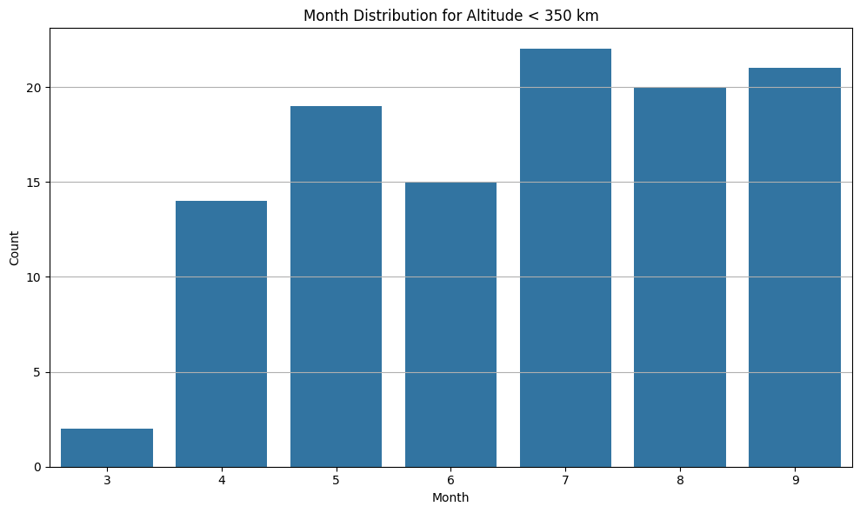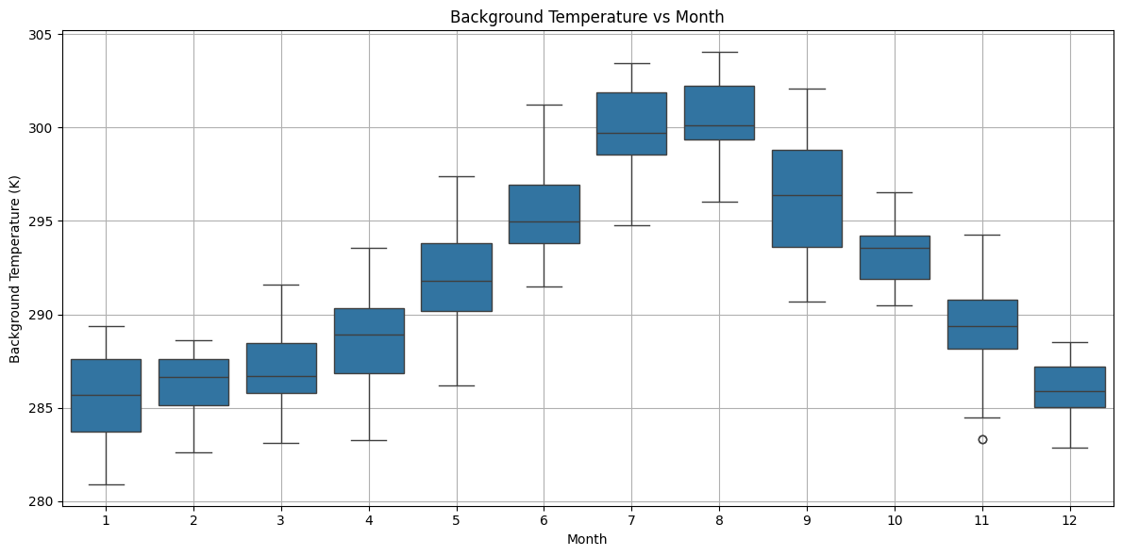

Figure 13: Month Distribution for Altitude < 350 km

This figure shows the monthly distribution of data points where the altitude is below 350 km. The low-altitude observations — which provide the highest SNR — predominantly occur during the warmest months, limiting the potential benefit of low background temperature.

Figure 12: Background Temperature vs Month

This figure shows how background temperature varies throughout the year. The highest temperatures occur during the warm months, while the coldest months offer lower background temperatures — conditions that are more favorable for achieving higher SNR.

**Related Reports**

* [Numerical Evaluation of the SNR](https://communitystudentiunina.sharepoint.com/:b:/s/IGNISCubeSatProject/Eft_3VZXh8tGp5IFOwETcDMBoZ1fjmmzoop5jFXzGk8nwA?e=60vv1C)
* [First Analysis and Results of the SNR](https://communitystudentiunina.sharepoint.com/:b:/s/IGNISCubeSatProject/EWCnloQeBPhCtSwv3KDntJ0BDfzRUW7LtaJMfcou0WirYA?e=huK5aL)

*Seyed Ali Rashidi*

*Payload*

*IGNIS*

*Pierluca De Felice*

*Head*

*IGNIS*